News & Notes 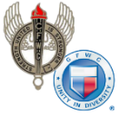 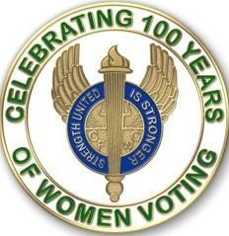
GFWC — an international women's organization dedicated to community improvement by enhancing the lives of others through volunteer service
Carol Weldin, Co-Liaison
May ~ Sheltering in Place and Staying Safe!

May 10-16: National Women's Health Week
Last week was National Women’s Health Week (May 10–May 16) this year is more important than ever as we all continue to cope with the COVID-19 pandemic. Pull out your sewing machine—or needle and thread—to make protective masks for women who are medical personnel, police officers, nursing home personnel, grocery store clerks, or serving in other roles on the front lines.
These masks are not used in place of the N95 masks. However, they could be worn in place of respiratory masks by a medical person or other essential worker when performing tasks other than ones involved with the Coronavirus, and thus save the infection preventing masks. Please read and adhere to the guidelines below governing this project.
- Do not go to the fabric store to purchase materials for this project unless you are in a non-restricted travel state.
- If you have the materials at your home and other members of your club have offered to assist you in the sewing of some, drop the materials off in their mailbox and have them return the finished masks to you in your mailbox.
- Visit the Turban Project website.
- Suggestions: Apply interfacing to fabric, put right sides of fabric together and add one more layer of fabric. Be sure to double sew across elastic. Fabric should be tight-weave cotton fabric.
- When you have finished the masks call your hospital/primary care physician, police department, grocery store, nursing home, or town health department to arrange a drop off, being sure to tell them that these are non-infection masks.
- Above all, take care of yourself. It is not a help if you put yourself or members of your club at risk for the Coronavirus.
And, don’t forget to snap a photo of your completed masks—or host a Zoom meeting of you making them with other club members—before distributing them. Submit your brief write up to pr@gfwc.org to be considered for the GFWC Blog.

Planned Any Home Life Projects Lately?
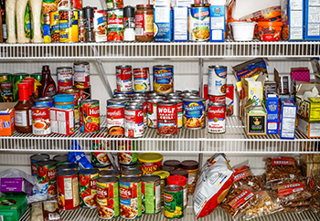
This is another opportunity to celebrate last week’s National Women’s Health Week: Schedule a Zoom meeting with some members of your club to start planning a Home Life Program-oriented project that can be done remotely over the upcoming weeks. Consider the following ideas from GFWC’s Home Life Community Service Program Chairman Carolyn Forbes on how you and your club can live the volunteer spirit remotely while supporting awareness of health issues.
- Schedule a digital workshop to promote adult immunization. Go to www.cdc.gov and type in immunization for access to resources to share with clubs that can help members understand why vaccination is important and which vaccines are recommended for them.
- Chances are your usual routine has been shaken up, making it more challenging to maintain healthy habits and prepare nutritious meals. Make the most of what you have in your pantry and share your heart-healthy recipes with your GFWC sisters by email, FaceTime, or another digital communication.
- Write a letter of gratitude and thanks to the local police department, hospital staff, or other first responders in your community.
Remember, there is nothing stronger than a healthy volunteer!
Partner with March of Dimes While Sheltering at Home During the Pandemic
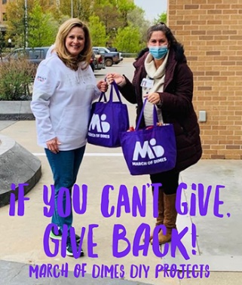
Ready to do something to help friends, neighbors, and even folks we’ve never met? March of Dimes Volunteer Opportunities website offers DIY activities in addition to making baby blankets and hats.
- Write Notes of Hope. It can be a scary time for a mom or dad with a baby in the NICU. Send words of encouragement to families or healthcare workers. It just takes a moment to send a digital note.
- Make Cloth Face Coverings. The CDC recommends cloth face coverings to add a protective measure, in addition to social distancing. March of Dimes can provide branded material or you may use your own.
- Gratitude Gifts for Healthcare Providers. Organize, purchase, or solicit in-kind donations for gratitude gifts and meals for those serving the public.
Contact Amy Richardson for more information.
Johns Hopkins COVID-19 Website:
The Johns Hopkins COVID-19 website remains an important source of updated medical and epidemiologic information that will help you protect yourself and your loved ones
Suffrage at 100: The Symbols of Suffrage
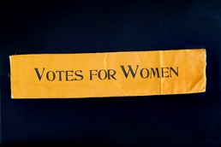
From the National Museum of American History Collection
What proponents of the suffrage movement wore were just as important as what they said. This month, we’re exploring some different symbols of the movement and what they meant to those who wore them.
The Suffrage Colors
In 1908, the Women’s Social and Political Union in England adopted the colors of white, purple, and green to distinguish their political movement for the right to vote. In 1867, gold replaced green in tricolor displays when suffragists from Kansas began using gold as a representative of their state flower: the sunflower. From then on in the United States, gold was incorporated into suffrage displays.
A 1913 edition of The Suffragist, a weekly newspaper published by the Congressional Union for Woman Suffrage, stated that: “Purple is the color of loyalty, constancy to purpose, unswerving steadfastness to a cause. White, the emblem of purity, symbolizes the quality of our purpose; and gold, the color of light and life, is as the torch that guides our purpose, pure and unswerving.” Learn more about suffrage colors.
The Suffrage Sash
Sashes were worn at parades and rallies to show loyalty to the suffrage movement. Different organizations such as the National Woman’s Party and the Women’s Political Union made their own sashes. However, they were usually adorned with the one or all the suffrage colors. “Votes for Women” was the most popular slogan embroidered on the sashes.
Check out this sash from the National Museum of American History!

The Yellow Rose
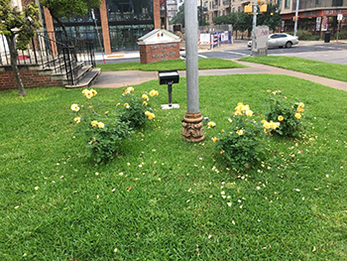
The rose bush planted in Austin during the 2019 GFWC Annual Convention left a mark at the GFWC Texas Headquarters.
The yellow rose gained national attention in 1919 when Tennessee became the final state to vote in favor of the 19th Amendment and ensure its ratification. “Antis,” people who were against women’s suffrage, wore a red rose to symbolize a “no” vote. Representatives who planned to vote “yes” adorned themselves with a yellow rose. Notably, the vote which ensured the passage of the amendment was passed by Harry T. Burn. Harry, the youngest member of the State Legislature, had planned on voting “no” until he received a letter from his mother Febb E. Burn. Febb, a GFWC clubwoman, implored Harry to be a “good boy” and vote “yes.” Learn more about Febb and Harry Burn and the yellow rose!
Interested in learning more about suffrage symbolism and history? Check out these great resources:
- Women’s Suffrage Memorabilia Exhibit
- Symbols of the Women’s Suffrage Movement
- Woman Suffrage: Treasures of American History
GFWC Supports Continued Funding for the World Health Organization
GFWC, at the request of United Nations Foundation Shot@Life Campaign, has signed a letter to President Trump urging the continued support of the World Health Organization (WHO) with copies of the letter going to Secretary of State Mike Pompeo, Secretary of Health and Human Services Alex Azar, Speaker of the House Nancy Pelosi, Senate Majority Leader Mitch McConnell, House Minority Leader Kevin McCarthy, and Senate Minority Leader Chuck Schumer. Visit the Advocacy in Action page for more information.

May 25: Plan to Remember Military Women
What do GFWC volunteer projects to honor women in the military look like amidst the constraints of the COVID-19 virus? Here are a few ideas for you from GFWC’s Public Issues Community Service Program Chairman Celene Post that are just in time for Memorial Day!
- If there is a female veteran in the neighborhood, how about providing her with a picnic basket? If you don’t feel like getting out the grill, perhaps a “hero” sandwich would work. Add a bag of chips, potato salad, and brownies for dessert. Set it on the porch with a note attached!
- You could make a rag wreath and leave it on the doorstep. You can get wire from online craft stores with material strips of red, white, and blue tied on.
- Deliver a grocery store-made apple pie. Slip it in a plastic bag and attach a patriotic sticker. If you are not sure of any dietary restrictions, perhaps a small plant or cactus with a mini flag and a note might be the perfect way to say “thank you for your service!”
After completing one of the above projects, be sure to share your success stories to be considered for posting on GFWC’s Blog. Email pr@gfwc.org a summary of your project along with a compelling photo.

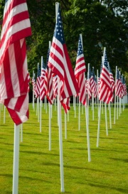

*LAST MONDAY IN MAY*

National Moment of Remembrance – at 3 PM local time on Memorial Day, the Memorial Day Foundation asks for 60 seconds of silence to remember U.S. service members, past and present, and their sacrifices for our country. 3 PM was selected as it represents the time when most Americans would be enjoying their freedom with a Memorial Day BBQ…….on a much smaller scale, if any, of course, this year. If displaying the flag, it is appropriate to display it at half-staff until noon. Yolanda Petroski, Public Issues Chairman

We pause to remember those who died
With so much courage, so much pride.
They’ll never come back but memories endure.
We’re worthy of their sacrifice
If we pause each day
Not just on
The last Monday in May

