News & Notes 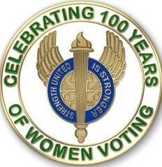
GFWC — an international women's organization dedicated to community improvement by enhancing the lives of others through volunteer service
Carol Weldin, Co-Liaison
May ~ Sheltering in Place and Staying Safe!
Suffrage at 100: The GFWC Clubwoman as Suffragist
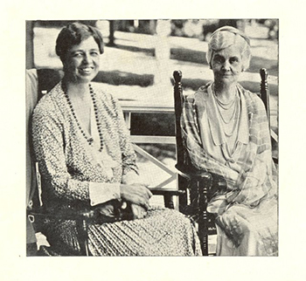
In 1914, GFWC threw the weight of its millions of clubwomen behind the American suffrage movement. Their endorsement of the 19th Amendment helped to lend credibility and momentum to a movement that had been stalling just a few years earlier. Clubwomen across the country marched, protested, and advocated to help ensure the ratification of the 19th Amendment in 1920.
Learn about a few of GFWC’s most illustrious advocates for the vote below!
Julia Ward Howe
Born in New York City in 1819, Julia Ward Howe became one of the 19th century’s most influential women. A writer, abolitionist, suffragist, lecturer, and clubwoman, Julia Ward Howe surrounded herself with notable writers and creators from a young age.
In 1862, Howe’s poem “The Battle Hymn of the Republic” was published for the first time in Atlantic Monthly. Battle Hymn is still considered the Civil War anthem of the Union and is Howe’s best-known publication. After the war, Howe helped to establish and lead major women’s organizations, including GFWC. Other groups Howe helped to establish include the New England Suffrage Association, the Massachusetts Woman Suffrage Association, and the National Woman Suffrage Association.
Eva Perry Moore
Eva Perry Moore dedicated her life to club work and the advancement of women. Moore was a charter member of the Wednesday Club in St. Louis and served as its president from 1892–1894. Moore also served as the Missouri Federation of Women’s Clubs’ President from 1901–1906, and as GFWC International President from 1908–1912. Additionally, Moore served as President of the Association of Collegiate Alumnae (which later became the AAUW) and of the National Council of Women. As GFWC President, she focused on education, public health, and children’s issues.
Moore also used her position as a leader in women’s issues to advocate for suffrage. In 1906, as president of the Association of Collegiate Alumni, Moore spoke at the National American Woman Suffrage Association convention alongside Susan B. Anthony. At the Convention she insisted that ‘We have no platform unless it is the care of women and children, and the home, the latter meaning the four walls of the city as well as the four walls of brick and mortar.”
Anna Pennybacker
Anna Pennybacker, who is pictured above sitting beside Eleanor Roosevelt, was an accomplished suffragist, educator, author, peace activist, and clubwoman. Born in Virginia, Pennybacker moved to Texas at an early age where she had an indelible impact on Texas history and education.
Pennybacker worked as a teacher in Texas and published A New History of Texas in 1888. The textbook was used in state curriculums for over forty years. In 1894, Pennybacker established the Tyler Woman’s Club, one of Texas’s first clubs. From 1901–1903 Anna led the Texas Federation of Women’s Clubs, and from 1912–1916 she served as President of GFWC.
Pennybacker lectured extensively throughout Texas to promote women’s education and suffrage. From 1919–1920 Pennybacker also served as an associate member of the Democratic National Committee, where she formed an influential and lifelong friendship with First Lady Eleanor Roosevelt.
Curator's Corner
Poetry, Literacy, Activism, and the Suffrage Movement
In 1868, Jane Cunningham Croly, a journalist and future founder of GFWC, organized Sorosis. The new club was established as a refuge for women to openly discuss intellectual ideas, literature, and their own pieces of writing. In the mid-19th century, the act of women writing and gathering for professional purposes was a radical action.
That same year, Susan B. Anthony began publication of The Revolution, the first newspaper in the country dedicated to women’s suffrage. By 1890, the year of GFWC’s founding, another 33 suffrage newspapers were in print. Much like how Jane Cunningham Croly used her own newspaper columns, the act of writing gave suffragists a base to disseminate their ideas and grow their base. However, this was not just limited to journalistic writing. Suffragists used poetry and fiction to propagate their message and help to intertwine it into popular culture.
Suffragists used popular forms of literature, such as poetry, to forward their political campaign through humor and empowerment. Avenues such as this book of suffrage nursery rhymes granted them space to enter popular culture, express their views, and even mock male authority. Other poems, such as Charlotte Perkins Gilman’s We As Women sought to embolden and excite fellow suffragists:
“There's a cry in the air about us–
We hear it, before, behind–
Of the way in which "We, as women,"
Are going to lift mankind!
With our white frocks starched and ruffled,
And our soft hair brushed and curled–
Hats off! For “We, as women,”
Are coming to save the world…”
Suffragists wrote and published their own books of poetry and helped to promote and popularize the movement within the American consciousness. As we celebrate the centennial of the 19th Amendment, let’s also remember to celebrate its enduring legacy of American poetry and literature.
To learn more about GFWC’s poetry collection, visit our online collections
Suffrage at 100: The Symbols of Suffrage
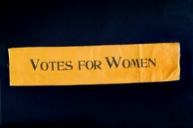
From the National Museum of American History Collection
What proponents of the suffrage movement wore were just as important as what they said. This month, we’re exploring some different symbols of the movement and what they meant to those who wore them.
The Suffrage Colors
In 1908, the Women’s Social and Political Union in England adopted the colors of white, purple, and green to distinguish their political movement for the right to vote. In 1867, gold replaced green in tricolor displays when suffragists from Kansas began using gold as a representative of their state flower: the sunflower. From then on in the United States, gold was incorporated into suffrage displays.
A 1913 edition of The Suffragist, a weekly newspaper published by the Congressional Union for Woman Suffrage, stated that: “Purple is the color of loyalty, constancy to purpose, unswerving steadfastness to a cause. White, the emblem of purity, symbolizes the quality of our purpose; and gold, the color of light and life, is as the torch that guides our purpose, pure and unswerving.” Learn more about suffrage colors.
The Suffrage Sash
Sashes were worn at parades and rallies to show loyalty to the suffrage movement. Different organizations such as the National Woman’s Party and the Women’s Political Union made their own sashes. However, they were usually adorned with the one or all the suffrage colors. “Votes for Women” was the most popular slogan embroidered on the sashes.
Check out this sash from the National Museum of American History!

The Yellow Rose
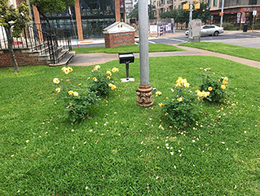
The rose bush planted in Austin during the 2019 GFWC Annual Convention left a mark at the GFWC Texas Headquarters.
The yellow rose gained national attention in 1919 when Tennessee became the final state to vote in favor of the 19th Amendment and ensure its ratification. “Antis,” people who were against women’s suffrage, wore a red rose to symbolize a “no” vote. Representatives who planned to vote “yes” adorned themselves with a yellow rose. Notably, the vote which ensured the passage of the amendment was passed by Harry T. Burn. Harry, the youngest member of the State Legislature, had planned on voting “no” until he received a letter from his mother Febb E. Burn. Febb, a GFWC clubwoman, implored Harry to be a “good boy” and vote “yes.” Learn more about Febb and Harry Burn and the yellow rose!
Interested in learning more about suffrage symbolism and history? Check out these great resources:
- Women’s Suffrage Memorabilia Exhibit
- Symbols of the Women’s Suffrage Movement
- Woman Suffrage: Treasures of American History
GFWC Supports Continued Funding for the World Health Organization
GFWC, at the request of United Nations Foundation Shot@Life Campaign, has signed a letter to President Trump urging the continued support of the World Health Organization (WHO) with copies of the letter going to Secretary of State Mike Pompeo, Secretary of Health and Human Services Alex Azar, Speaker of the House Nancy Pelosi, Senate Majority Leader Mitch McConnell, House Minority Leader Kevin McCarthy, and Senate Minority Leader Chuck Schumer. Visit the Advocacy in Action page for more information.
Johns Hopkins COVID-19 Website:
The Johns Hopkins COVID-19 website remains an important source of updated medical and epidemiologic information that will help you protect yourself and your loved ones

Conserve the Beauty of Our Planet at Home

You may be stuck at home, but that doesn’t mean you can’t enjoy the beauty of the world. Conservation Community Service Program Chairman Angela Cutrera has some ideas on how you can appreciate and take care of our planet while staying safe during this pandemic.
- Tour the vast landscapes of a National Park virtually.
- Make future plans to design a garden and research all of the fruit tree, vegetable plants, and flower possibilities online.
- Research the animals and wildlife in your area. Keep a list and compare with friends for the number, differences, and unexpected!
- Plant an indoor herb garden or terrarium.
- Create art using recyclables. Plastic caps from drink bottles come in many different colors and sizes.
- Design your own deck of playing cards using scrap paper.

Be sure to share your success stories with pr@gfwc.org to be considered for posting on GFWC’s Blog! Snap a photo of your club working on a project virtually together and include a summary of your project accomplishments.

