GFWC News & Notes 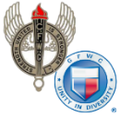 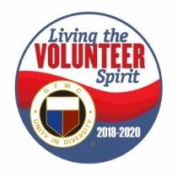
GFWC — an international women's organization dedicated to community improvement by enhancing the lives of others through volunteer service
Carol Weldin, Co-Liaison
March 2020

From the Desk of President Dori ~ March 16, 2020
We have been following all the Presidential & Gubernatorial announcements with your interests in mind. I have also been watching what other GFWC State Presidents are doing and waiting to hear more about what will be happening. We suggest that large meetings be cancelled in the short term, I believe the suggestion is 50 or more people. The choice is yours if you want to cancel smaller meetings.

Please if your meeting has been canceled do not second guess your Officers. This a difficult thing for the Presidents of Clubs and Districts to do. Stand behind them, please. They cancel meetings because they are thinking of you.

We have heard from the GFWC Parliamentarian about what the National Group of Parliamentarians suggest for elections and things that we would be doing at our Conventions. I have asked Priscilla Bolinder, our CFWC Parliamentarian to review that document for us and we will have something for you by mid-week. I have sent the information out as received to all the District President yesterday. So, you can see what it was. Note, that this is a change from Saturday’s post on Facebook. I felt you needed to see the information.

When thinking about canceling a meeting please think about the size of the group, then where you are going to meet, and the age group and health of your members. I trust you will all do the right thing for your own members. I do believe because of the emergency declaration from the President Trump canceling venues should not be a problem. Remember that Pam, Priscilla, Barbara and I as well as the rest of the Executive Committee are thinking of what is best for you and all our members.

From Donna Shackel, CFWC Home Life Chair
Join the Academy of Nutrition and Dietetics in celebrating National Nutrition Month this March!
During the month of March, everyone is invited to focus on making informed food choices and developing sound eating and physical activity habits.
Check out this Nutrition toolkit for tip sheets, games, activities, press releases and planning materials. You will also find a social media toolkit.
https://www.eatright.org/food/resources/national-nutrition-month/toolkit

A Must-Read this March on Women's Suffrage
by Sharon Sheridan, GFWC ESO Chairman
As part of your Women's History Month observance, I recommend picking up a copy of American Suffragists and the Battle for the Ballot by Winifred Conkling. The Florida Epsilon Sigma Omicron Society is already reading it, and it would be a great book for the entire Federation’s celebration of the centennial of the 19th Amendment. A book for young adults, it’s an easy read while still providing a comprehensive history. The book also contains photography, a timeline, and a bibliography. This book is excellent for encouraging Juniorettes to learn about all of the brave women who cleared the way for where we are today. Consider giving a copy to each of your club’s Juniorette members in conjunction and purchase copies for your local public libraries.
American Suffragists and the Battle for the Ballot is available on Amazon in hardcover, paperback, Kindle, and audio book formats.
A Fantastic Women's History Month Event
On Thursday, March 5, GFWC celebrated Women’s History Month with our annual Women’s History Month Celebration.This year was an extra special occasion, as 2020 marks the 100th anniversary of the ratification of the 19th Amendment.
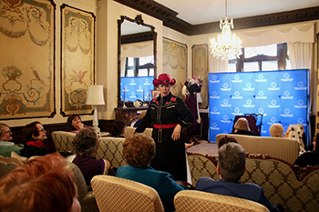
Kate Campbell Stevenson, a classically trained actress and musician, brought Headquarters to life with her one-woman show, Amending America: How Women Won the Right to Vote through a rousing musical performance. Amending America introduced the stories of Abigail Adams, Rose Crabtree, and Alice Paul, and how they influenced the fight for women’s suffrage. Kate’s closing number celebrated “standing on the shoulder of giants,” and paid homage to those who carved a path for the women of today.
Following Kate’s routine, the Executive Committee, clubwomen, and members of the public mingled at a celebratory reception.
Annual Shot@Life Champion Summit Recap

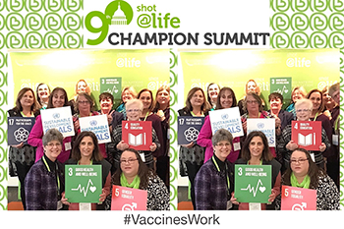
In case you missed it, last week Shot@Life held its 9th Annual Shot@Life Champion Summit in Washington, D.C. It was another record-breaking year, with more than 120 grassroots advocates and supporters from across the country joining Shot@Life for its annual three-day Summit. Champions heard from global health experts, Washington policy insiders, Shot@Life team members, and fellow champions!
Included in the amazing attendees were 14 GFWC clubwomen, covering numerous states and ranging from champions who are leaders in their states to five champions who were experiencing their very first Summit. Throughout the day on Capitol Hill, Shot@Life reached more than 155 offices, with GFWC members attending a total of 68 of those meetings with their respective groups! GFWC International President, Mary Ellen Brock, joined the team Tuesday night for dinner and conversation.
Please help continue their momentum by participating in Advocate2Vaccinate throughout April! This annual fundraising and advocacy push is open to champions and general supporters alike, and more information can be found at shotatlife.org/gfwc.
Championing an International Organization ~by Mary Kaye Ernest, GFWC International Liaisons Chairman
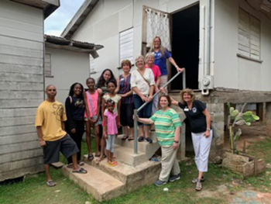
Why is it important that GFWC is an international organization and how do International Affiliates fit within the structure?
Being an international organization strengthens GFWC’s voice and advocacy for women worldwide. No matter where in the world we live, an international viewpoint benefits all club members. Our International Affiliates connect the organization to areas of need in our world and show us a way that we can play a part in helping. Having international connections allows us to reach out to the International Affiliates in providing them with aid, manpower, and resources.
International Affiliates include: Aruba, Belize, Brazil, Canada, Cyprus, The Bahamas, Netherlands Antilles, Peru, The Philippines, Taiwan, Uganda, Ukraine, and Korea, which just rejoined the Federation.
The last week of February, a group of six GFWC members from the United States traveled to Belize for a service project. PathLight International, along with the four GFWC Belize Clubs, arranged for a service project within Belize City. The projects included providing clothing and dental health products for school children, as well as visiting the homes and schools of the Juniorette members.
These are just some of the reasons why it is important for International Affiliates to be a part of the GFWC organization.
PCAA: Child Abuse Prevention Month
Everybody plays a part in preventing child abuse and neglect. From a firefighter in Fremont, CA, who reads to after-school groups at the local public library to help ease stress on parents in her neighborhood, to a noodle bar manager in Raleigh, NC, who launched “$1 Ramen Day,” a fundraising event where every purchase (and every tip) benefits his local chapter—these are the people taking small but impactful steps to help children, families, and entire communities thrive. That's how Prevent Child Abuse America arrived at its 2020 Child Abuse Prevention Month (CAP Month) theme: “Everyone can make great childhoods happen—especially you!” You don’t need to have special skills to help make great childhoods happen—just be willing. To learn more about how you can participate in CAP Month, visit PCAA’s website.
State Director's Project: South Carolina, Carrie Zimmerman
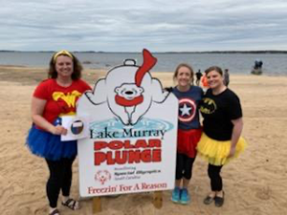
The Director of Junior Clubs for South Carolina’s special project is Special Olympics. Special Olympics are meaningful to Carrie Zimmerman because of her daughter’s passion to work with this population and programs. This Director has volunteered with Special Olympics since she was a young elementary student too.
The goals for the project were to locate local Special Olympic activities or special education sports programs in club members’ respective communities and support by either, volunteering, fundraising, financial assistance, and/or supporting local sports that serve this population. A superhero theme was used to promote this Director’s project at GFWC South Carolina club meetings and conventions.
This Director used three categories of Supergirls: “BAM,” “Wonder Woman –“POW” and Superheroes – “ZAP,” to highlight the projects and choose winners throughout the state. Many GFWC South Carolina clubs, Junior and Women’s alike, supported throughout this Administration and continue to highlight through social media and State Convention Awards. The impact brought awareness and support to many local South Carolina communities and Special Olympic events.
One club, Junior Woman’s Club of Lake Murray, has participated the last two years in a local polar plunge, dressing up as superheroes and raising funds for their local Special Olympics “Freezin’ for a Reason” and plunging into the lake. This Director participated in February 2019.
Register for the 2020 Women's History Month Event
Did you know that Abigail Adams became the first First Lady to have been appointed to a federal position? Or that Alice Paul formed the National Woman’s Party when she was only 31 years old? Learn more about these incredible women and others at GFWC’s Women’s History Month celebration on March 5 from 2–4 p.m.!
This year, GFWC will celebrate the 100th anniversary of the 19th Amendment with a performance by Kate Campbell Stevenson. Kate’s one-woman show, Amending America: How Women Won the Vote, will illuminate forgotten stories of the suffrage movement. She will highlight women such as Abigail Adams, First Lady and advocate for women’s rights, Rose Crabtree, a member of the 1920 all-female town council of Jackson Hole, and Alice Paul, co-founder of the National Woman’s Party. Kate’s performance also encourages women to become more active participants in the political process.
To register, please visit the Member Portal!

From Donna Shackel, CFWC Home Life Chair ~ March 9th was National Napping Day
Observed annually the day following the return of daylight saving time provides everyone with the opportunity to have a nap and catch up on the hour of sleep they lost due to the spring forward time change.
William Anthony, Ph.D., a Boston University Professor and his wife, Camille Anthony, created National Napping Day in 1999 as an effort to spotlight the health benefits to catching up on quality sleep.
Needed rest can make you feel better, improve your mood, and make you more productive and energetic. Numerous studies have shown that short 10-20 minute naps are the most effective when midday fatigue hits.

March 12th was World Kidney Day
The purpose was to raise awareness of the importance of kidneys to overall human health and inform the world about ways to prevent kidney disease.
1. Keep active and fit
2. Control your blood sugar
3. Monitor blood pressure
4. Monitor weight and eat a healthy diet
5. Drink plenty of fluids
6. Don’t smoke
7. Be aware of the amount of OTC pills you take
8. Have your kidney function tested if you’re at high risk

From the desk of President Dori Kelsey
It was wonderful to see that 11 clubs reported supporting the Honor Flight Program. This is up from the 5 clubs in 2018. Here is another way clubs can participate – especially if they are not located near ones of the hubs. Honor Flight Southland which leaves from LAX put out a request for notes of appreciation which are distributed to the veterans during “Mail Call” on the way to D.C. Family and friends do send notes, but words of encouragement and appreciation from strangers are welcomed also, and I’m told the veterans appreciate and treasure them all. Check the dollar stores for note cards. Also check the hubs if they also have “Mail Calls” or anything else you could help with. Currently, Honor Flights leave from Fresno, San Francisco, San Luis Obispo, Bakersfield, Ontario, LAX and San Diego. Go to www.honorflight.org and click on California, then Hubs/Flights. Contact information for each hub is listed, along with their scheduled 2020 flights. Check with the one closest to you. Having shook the hand, looked into the eyes, and personally thanked a veteran who stormed the beach at Normandy, this project has touched my heart. QuickBytes – Yolanda Petroski

We had a wonderful CFWC State Board Meeting in Sacramento. We did great things for Foster Kids both Friday and Saturday nights. The Taylor House gave us a look at what Lisa Peat and her staff are doing for timed out foster care young ladies after the system lets them down. We did give this organization a check from CFWC to help them keep up their great work!
Ticket to Dream helps foster kids with sleepwear, books, sports equipment and money to do things that some things foster kids never get to do. We had a few back packs & bags for them, a suitcase plus a $300 donation. $200 were donations from the floor and a Target gift card. The big thing was that our PJ wearing members donated a total of 165 different pairs of PJ’s and night gowns! Plus, we had a blast in our own night wear! Everyone looked so cute. The 2 ladies who came to speak were so thrilled with that huge amount of sleepwear. They sounded so excited to get all our donations! It was great to see. I am so proud of our ladies, and their giving hearts.

