GFWC News & Notes 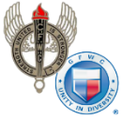 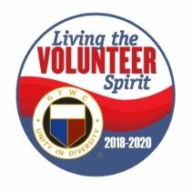 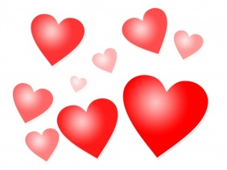
GFWC — an international women's organization dedicated to community improvement by enhancing the lives of others through volunteer service
Carol Weldin, Co-Liaison
February 2020

Raise Awareness about Preventing Teen Dating Violence
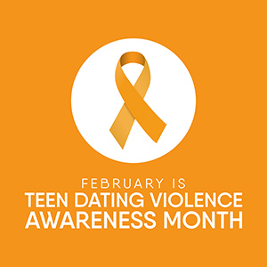

It’s important for teenagers to know what a safe and healthy relationship looks and feels like, especially if it’s their first one. They might not recognize abusive patterns or behaviors. They also might only know how to identify physical abuse and not psychological, emotional, and digital abuse (using technology such as cell phones or social media to abuse and control). Visit www.loveisrespect.org to educate yourself and youth in your community on teen dating violence, indicators, and healthy relationships. Use GFWC’s Action Guides as resources!
Suffrage at 100
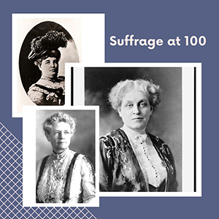
Over the next six months, News & Notes will feature a monthly column which explores suffrage and the 100th anniversary of the 19th Amendment.
The 19th Amendment was ratified on August 26, 1920, and prohibits state and federal governments from denying citizens the right to vote on the basis of their sex. The motion for women’s suffrage was first submitted to congress in 1878, but its ratification was the culmination of 72 years of formal organizing and the work of thousands of activists.
The groundwork for the suffrage movement was laid in 1848, when women and men led by Elizabeth Cady Stanton, Susan B. Anthony, and Lucretia Mott met in Seneca Falls. As suffrage grew in popularity, proponents of the movement were not always united and it produced leaders of differing backgrounds and opinions. Although the National Women’s Suffrage Association and the American Women Suffrage Association both worked towards the same goal, issues of race and tactical approach separated them.
In 1890, the two groups united to capitalize on a new surge in support for suffrage. Although the majority of American women had previously been apathetic, the popularity of women’s volunteer organizations forged new roles for women and helped to legitimize the previously unpopular suffrage movement.
The National Women’s Party, led by Alice Paul, began picketing in 1913 and holding marches and mass rallies to gather support. These actions, and the subsequent imprisonment of suffragists, helped to buoy public empathy and support for the women. The public pressure eventually led to support from President Woodrow Wilson. The Amendment was finally supported by Congress in June 1919 and was officially ratified in August 1920.
Although the passage of the 19th Amendment granted 26 million women the right to vote, those protections did not extend to African American, Asian American, Hispanic American, or Native American women, among other minority groups. All Americans would not be fully enfranchised until 1965 when the Voting Rights Act was passed—another historic milestone.
Please kick of your own observation efforts by registering for the 2020 Women’s History Month Event on March 5, from 2–4 p.m. This year’s event will feature Kate Campbell Stevenson. Kate’s one-woman show, Amending America: How Women Won the Vote!
One Month Away: Dr. Seuss' Birthday
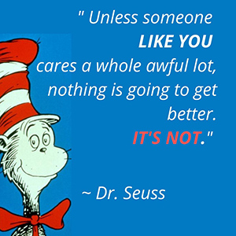
Your club’s volunteer spirit is needed March 2 on Read across America Day, which is also Dr. Seuss’ birthday. GFWC cares a whole awful lot about giving children in need the opportunity to read. Last year, clubwomen throughout the Federation participated in the Dr. Seuss Grand Initiative, resulting in 50,716 books being donated to children in need.
But the lives of children in your community could still get better! Help to ensure 4,200+ more books are donated by June 30 to schools, Head Start programs, and other places dedicated to making a difference in the lives of children.

Great Bridge Woman's Club Visits Operation Smile
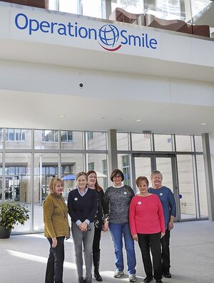
As early as 1988, Great Bridge Woman's Club (GBWC) in Chesapeake, Virginia, was collecting items and making monetary donations to GFWC Partner Operation Smile. Back then, items collected included bandages, cough syrup, combs, magic markers, and coloring books.
During the 1990's, GBWC hosted speakers from Operation Smile and continued to collect items to assemble Smile Bags. The club also made Smile Dolls and hospital gowns for the young patients. A donation of $125 was given to the Smile Pin Campaign, and club members worked at Rowena's Bakery in Norfolk, Virginia, and donated their “salaries” of $260 to Operation Smile.
As 2000 approached, GBWC never forgot the wonderful work that Operation Smile had accomplished for patients and families around the world. GBWC collected small stuffed animals, travel size toothpaste, coloring books, and other needed items, and packed smile bags. In 2014, club members were invited to tour the new Operation Smile facility in Virginia Beach. They got to meet Hennglie Dorival, a young Haitian girl who had been brought to the area to have a very large facial tumor removed; the procedure could not safely be performed in her home country. Seeing her joy and confidence after having received the surgery inspired GBWC to become even more involved with the positive impact that Operation Smile was making.
In 2019, GBWC donated 19 large wheeled suitcases to Operation Smile to meet a growing need. GBWC then hosted Cindy Raglin, retired vice president of Quality Assurance, at a meeting who shared her passion for what Operation Smile means to so many children and families. GBWC also heard from Partners in Health Haiti about efforts to improve health care in that area.
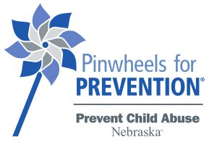
GFWC Nebraska Director of Junior Clubs, Kathy Huggins, has chosen Prevent Child Abuse Nebraska for her special project. One of GFWC’s Partners, Prevent Child Abuse America is the leading national, not-for-profit organization whose sole mission is “to prevent the abuse and neglect of our nation’s children.” The national organization is dedicated to promoting the healthy development of children through state chapters, public awareness, and advocating for national changes in policy that promote a nationwide prevention network. They provide outreach materials, research, evidence-based prevention practices, and training to help the statewide community councils maximize effectiveness in implementing prevention programs.
In 2008, Prevent Child Abuse America introduced the pinwheel as the national symbol for child abuse prevention through “Pinwheels for Prevention.” By its very nature, the pinwheel connotes whimsy and childlike notions. In essence, it has come to serve as the physical embodiment, or reminder, of the great childhoods we want for all children. Prevent Child Abuse Nebraska promotes pinwheel gardens and other activities throughout the state for Child Abuse Awareness Month each April.
NFWC clubs have been encouraged to raise awareness of child abuse and promote healthy childhoods by planting pinwheel gardens. Kathy began by designing a GFWC Nebraska shirt, and they were sold at this fall’s District conventions. Now she is taking the profits raised from the shirt sales and using them to subsidize the purchase of pinwheels for Nebraska clubs that want to participate. The clubs are in the process of finalizing their orders in preparation for the April events.
The pinwheel reminds us of our own childhoods and the fact that all children deserve to be happy and healthy. Kathy is hoping to see pinwheels pop up all over Nebraska this year!
From President Dori
This is the group coming to the State Board Meeting on Saturday night and the group we will be giving the PJ’s and Night Gowns too. It is Called “Ticket to Dream”. They are the Folks Sleep Train and Mattress Firm give all their donations too as I understand it. They are based here in Roseville.
HELPING FOSTER KIDS JUST BE KIDS

AT THE TICKET TO DREAM FOUNDATION
We are dedicated to creating hope and opportunity for foster children across the nation, so they can just be kids. To us, hope starts with having shoes and clothing that fit, lifting their self-esteem. School supplies and access to computers so they have the tools they need to succeed in school. Getting to experience the joy of a gift under the tree, a trip to the zoo or joining a sports team. It’s ensuring they receive the life skills and job training, education support, and access to housing services upon aging out that allows them to heal and grow to reach their full potential. We want foster children across the country to thrive, but we can’t do it alone – we need your help.
Our Pajamas will be going to this group, any children or teen sizes will do.

Curator's Corner
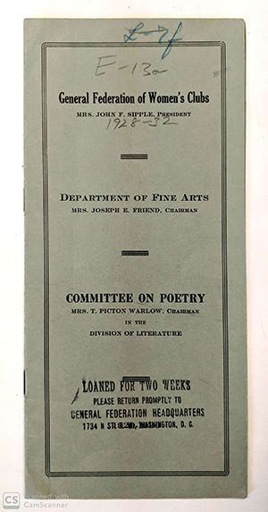
When journalist Jane Cunningham Croly founded Sorosis in 1868, she established it as a literary club for like-minded women. Croly was a strong advocate for women’s education and sought to carve out an intellectual space where women could read, write, and discuss ideas with each other. These literary seeds, which are rooted in the earliest days of GFWC, can be found planted throughout our history.
In 1890, when GFWC officially federated, the Literary Committee was one of the first committees to form. By the 1920s, GFWC’s Department of Fine Arts had branched out to develop a separate Committee on Poetry. The Committee regularly produced pamphlets which specified new poets and publications and “a course of study and program-building adapted to the individual needs of clubs which wish to devote either regular or occasional days to the study of poetry.”
Along with studying the recommended bibliography produced by GFWC, State Federations would also name Poet Laureates to represent their own regional style of poetry. Books from these poets, as well as poems published by clubwomen across the country, comprise GFWC’s State Poetry Collection.
Over the coming months, the WHRC will be digitizing the State Poetry Collection. These books, which were published in the early twentieth century and are primarily out of print, also make up a piece of the WHRC Rare Book Collection. View the State Poetry Collection.

.

