GFWC News & Notes 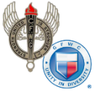 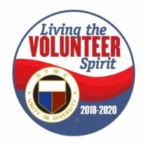
GFWC — an international women's organization dedicated to community improvement by enhancing the lives of others through volunteer service
Carol Weldin, AWC Co-Liaison
August 2019

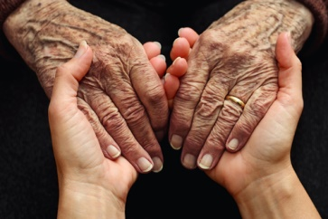

August 21 is World Senior Citizen’s Day to thank seniors for their contributions, be there for them through the aging process, and recognize issues like elder abuse. Here are some ways you can observe the day:
- Schedule a visit at a nursing home/assisted living facility. Quality time is an incredible gift for those who live in a nursing home. Bring a game or craft and socialize with seniors to keep them from feeling isolated.
- Volunteer for a service that benefits seniors. From meal delivery programs to senior programs at your local library, there are many ways you can volunteer and make a difference in a senior's life.
It’s important for seniors to maintain their physical, mental, and social engagement. You can help make that happen by planning a visit, project, or event to show the seniors in your community that you care!

Flag Days
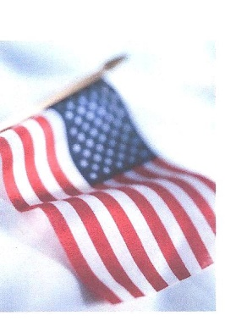
With the coming of September there are many occasions on which our flag should be displayed, starting with Labor Day, September 2. Always celebrated on the first Monday of September, the day honors the contributions workers have made to the strength, prosperity and well-being of our country.

Other flag-flying days include Patriot’s Day, September 11 (half-staff til noon); Constitution Day, September 17; and Air Force Day, September 17.

Although not a national holiday, POW/MIA Day September 21 is fast becoming a national observance in honor of the sacrifices of our POWs/MIAs. More than 82,000 Americans since WWII remain missing or unidentified. Check with your local communities and participate if activities are planned to honor them. Yolanda Petroski, CFWC Public Issue Chair

ESO (Epsilon Sigma Omicron)
The purpose of ESO is to provide clubwomen with a structural reading program, which is educational and stimulates a desire for self-improvement. Interested GFWC members must first pass through the ESO pledge stage before they can begin working towards membership status. After proper completion of 16 books read and reported on, the pledge receives a certificate verifying her ESO membership.

Different Levels of ESO are:
Member 4 books 4 different categories for a total of 16 books
Star 4 books 10 different categories for a total of 40 books
Torch 4 books 16 different categories for a total of 64 books
Century 1-9 a total of 100 books for each century
Diamond a total of 1,000 books
If you are interested in joining yourself or starting a new group please contact me. I will be glad to come to your club or district and help you get started. Information may also be found on the website GFWC.org under Education Chairman.
Lois Fitzhugh, Education Chairman, loisfitz4me@surewest.net , 916-749-7066 or cell 916-765-7985

Volunteers in Action
We're halfway through the summer, and we hope you're enjoying the season. Between recreation and soaking up the sun, make time for volunteering! With upcoming observances like the National Park Service Anniversary (August 25), there are many opportunities to engage with your community.
Email pr@gfwc.org with your summer success stories to be featured on GFWC's Blog.

Celebrate International Youth Day
August 12 was International Youth Day. The observance was designated by the UN in 1999 to bring awareness to challenges that youth face. This year’s theme is “Transforming Education,” which challenges us to make education inclusive for all. Here are a few ideas of ways to help:
- Support low-income students. Coming from a low-income family can pose challenges that make it difficult for children to focus in school. Collect backpacks, school supplies, winter clothing, and food for after-school meal programs.
- Support students with disabilities. Check with your local school board to learn how you can help the programs in your community or even start your own.
- Raise money for Heifer’s School Milk Project. With your help, students in Tanzania can focus on learning instead of on their empty stomach.
Plan an International Youth Day project to support students who face challenges accessing education and email your success stories to pr@gfwc.org

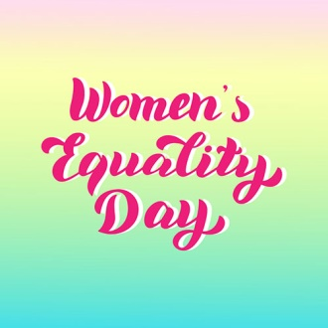
Plan For Women's Equality Day
We’re less than a month away from Women’s Equality Day on August 26. The day commemorates the adoption of the 19th Amendment, which gave women the right to vote. Here are a few ideas for how you can celebrate:
- Encourage women in your community to register to vote. With the next presidential election just over a year away, it’s the perfect time to inspire women to exercise the right that their foremothers fought for them to have. If you sponsor a Juniorette club, take the chance to talk to them about the importance of adding their voice to the political process.
- Honor the Woman Suffrage Procession of 1913, the first suffragist parade in D.C., by marching in a local suffrage parade in your community.
- Compile a list of women-owned businesses where you live. Supporting local businesses is an important way to give back to your community. Distribute the list to your club so they can celebrate women entrepreneurs.
One of GFWC’s new “Brand Initiatives” is to have 1,000 projects in place to celebrate the 100th anniversary of women’s suffrage on August 26, 2020. It may be a year away, but that gives you time to plan something spectacular. Get a head start by observing Women’s Equality Day this year!
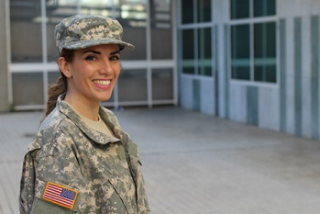
Support Women in the Military
One of the Seven Grand Initiatives is to complete 1,000 projects for women in the military by the end of the 2018-2020 Administration. At 799 projects to date, we’re so close! Labor Day is a month away, and it’s a fitting time to celebrate the women who have some of the most important jobs in our country.
- Create care packages for military women. Fill them with personal care items, such as deodorant, hair-bands and bobby pins, and feminine hygiene products. You can also include snacks, books, and a handwritten note to personalize your gift. Find an organization that sends care packages to military women and brighten a servicewoman’s day.
- Create Mommy Bags for military moms-to-be. Fill them with items such as diapers, wipes, lotion, lip balm, and small Kleenex packages. This is a great way to show military mothers that you care!
Plan your projects now and use Labor Day to acknowledge the women whose work involves defending our country.

